EXPERIMENT 4
NAME : Karthik V
ROLL NO : 240701234

Screen 1 :
Login Page
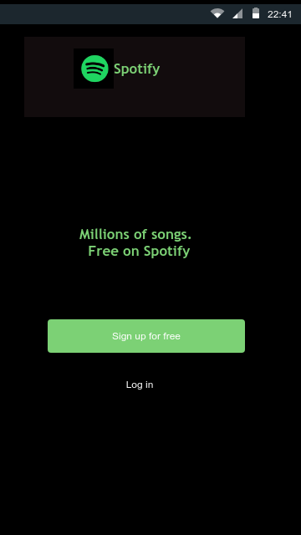
Screen 2:
Home Page
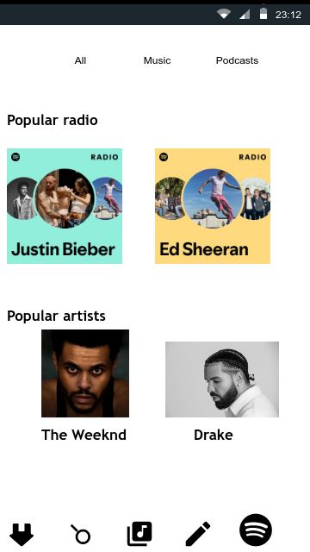
Familiar icons:
- Library icon: To See the User Library of the list of songs
- Create icon:
- Spotify Premium icon:

Unfamiliar icons:
- Home icon:
- Search icon:

Screen 3:
Playlist page:
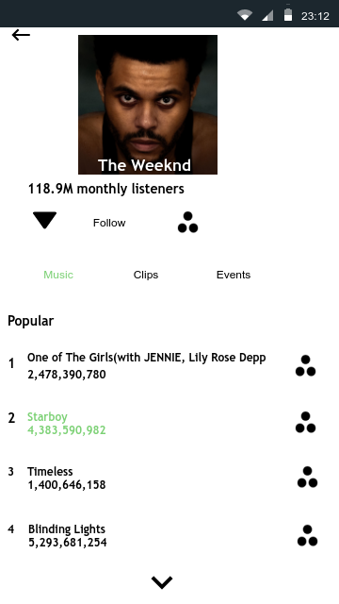
Familiar icons:
- Back Arrow icon:
- See More icon:
Unfamiliar icons:
- Menu icon:
- Play button:

Screen 4:
Play music
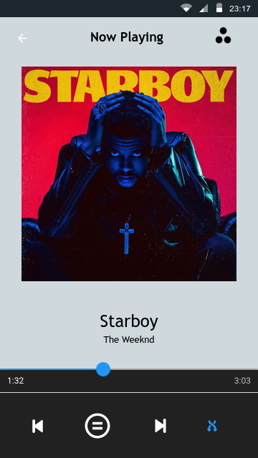
Familiar icons:
- Play next icon:
- Play backward icon:
- Back arrow icon:

Unfamiliar icons:
- Play button:
- Menu button:
Screen 5:
Lyrics Page
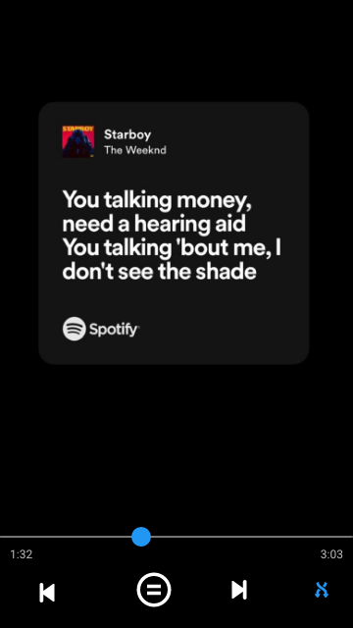

Familiar icons:
- Play next icon:
- Play backward icon:
Unfamiliar icons:
- Shuffle icon

